CENTRAL INDIA EXPORT
WWW.CENTRALINDIAEXPORT.COM

Ocular Prosthesis Artificial Eyes
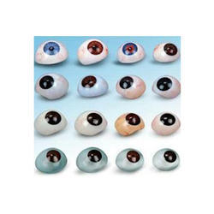
Product Details:
Material | Acrylic Powder
Size | 19mm to 28mm
Retina Color | Black, Dark Brown, Light Brown, Light Blue, Dark Blue, Green and other colors
Usage/Application | Ocular prosthesis
Color | Black, Dark Brown, Light Brown, Light Blue, Dark Blue, Green and other colors
Packaging Type | PACK OF 50
Shape | Oval
Sterile | Non-Sterile
Type | Acrylic Powder
Country of Origin | Made in India

